|  |
| --- |
| **Philly CRM 311**  **Technical Design – Smoke Detector**  **V1.0** |
|  |

# REVISION HISTORY

|  |  |  |  |
| --- | --- | --- | --- |
| **Revision Number** | **Revision Date** | **Summary of Changes** | **Author** |
| Draft | 04/30/2014 | Created Draft based on 1.6 of SR | Murugaboopathi |
| 1.0 | 05/01/2014 | Modified based on the Design Review | Murugaboopathi |

# 1 - TABLE OF CONTENTS

REVISION HISTORY 2

1 - TABLE OF CONTENTS 3

2 – SERVICE REQUEST INFORMATION 4

2.1 ENTITY RELATIONSHIP DIAGRAM 5

2.2.1 CASE STANDARD FIELDS 6

2.2.2 CUSTOM FIELDS 7

2.2.3 Dependent Picklist 9

2.2.4 Force.com Objects 9

2.3 HIGH LEVEL SYSTEM PROCESS FLOW 10

3 - NEW FUNCTIONALITY 11

3.1 CONFIGURATION DETAILS 11

3.2 DATA SHARING MODEL 14

3.3 CUSTOM DEVELOPMENT DETAILS 14

4 – STANDARD CASE FIELDS 19

4.1 DEPARTMENT DETAILS SECTION 19

4.2 CASE DETAIL/INFORMATION SECTION 20

4.3 SERVICE REQUEST LOCATION SECTION 22

4.4 CASE LOCATION SECTION 22

4.5 DESCRIPTION INFORMATION SECTION 23

4.6 RESOLUTION INFORMATION SECTION 23

4.6 WEB INFORMATION SECTION 24

4.7 SYSTEM INFORMATION SECTION 25

# 2 – SERVICE REQUEST INFORMATION

|  |  |
| --- | --- |
| **Case Record Type :** | Smoke Detector |
| **Service Request ID** | SR-FD02 Smoke Detector |
| **Service Request Type** | Smoke Detector |
| **Department** | Fire Department |

|  |
| --- |
| 2.1 ENTITY RELATIONSHIP DIAGRAM |



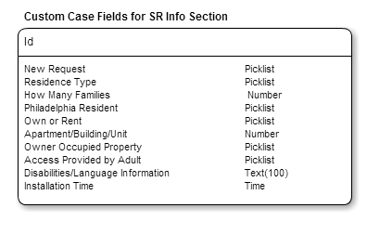

|  |
| --- |
| 2.2.1 CASE STANDARD FIELDS |

|  |  |  |  |  |  |  |  |  |  |
| --- | --- | --- | --- | --- | --- | --- | --- | --- | --- |
| **Field Label** | **Field Name** | **Data Type** | **Required** | **Unique** | **Default Value** | **External ID** | **Rule #** | **History** | **Help Text** |
| Status | Status | Picklist  **Values:** New, In-Progress, Escalated, On Hold, and Closed | Yes | No | New | No | None | Yes |  |
| Case Origin | Origin | Picklist  **Values:** Phone, Email, Web | Yes | No | Phone | No | None | Yes |  |
| Priority | Priority | Picklist  **Values:** High, Medium, Low | Yes | No | Medium | No | None | Yes |  |

|  |
| --- |
| 2.2.2 CUSTOM FIELDS |

|  |  |  |  |  |  |  |  |  |  |
| --- | --- | --- | --- | --- | --- | --- | --- | --- | --- |
| **Field Label** | **Field Name** | **Data Type** | **Required** | **Unique** | **Default Value** | **External ID** | **Rule #** | **History** | **Help Text** |
| New Request | New_Request__c | Picklist  **Values:** Yes, No | Yes |  |  |  | Workflow Rule #1 | No | Is this request for a smoke detector a new request? |
| Residence Type | Residence_Type__c | Picklist  **Values:** Single Family House, Apartment | Yes |  | This read-only field will be automatically populated from the GIS Zoning layer associated with the GIS record selected as the Service Request Location. |  | None | No | Is the residence a single family house or an apartment? |
| How Many Families | How_Many_Families__c | DEPENDENT Number  (Controlling field = *Residence Type*)  All values are shown if *Residence Type* = ‘Apartment’ | No |  |  |  | Workflow Rule #2 | No | How many families are in the apartment? |
| Philadelphia Resident | Philadelphia_Resident__c | Picklist  **Values:** Yes, No | Yes |  | This read-only field will be automatically populated from the GIS Zoning layer associated with the GIS record selected as the Service Request Location. |  | Workflow Rule #3 | No | Is the customer a resident of Philadelphia? |
| Own or Rent | Own_or_Rent__c | Picklist  **Values:** Own, Rent | Yes |  |  |  | Workflow Rule #4 | No | Does the customer own or rent the property? |
| Apartment/Building/Unit Number | Apartment_Building__c | DEPENDENT Number  (Controlling field = *Residence Type*)  All values are shown if *Residence Type* = ‘Apartment’ | Yes |  |  |  | None | No | What is the unit number of the apartment or building? |
| Owner Occupied Property | Owner_Occupied_Property__c | Picklist  **Values:** Yes, No | Yes |  |  |  | None | No | Does the customer live in an owner-occupied property? |
| Access Provided by Adult | Access_Provided_by_Adult__c | Picklist  **Values:** Yes, No | Yes |  |  |  | None | No | Will an adult (over 18) be present to provide access to the property? |
| Disabilities/Language Information | Disabilities_Language_Information__c | Text(100) | Yes |  |  |  | None | No | Is the customer hearing-impaired or have other disabilities? |
| Installation Time | Installation_Time__c | Time | Yes |  |  |  | None | No | What will be the best time of day for the Fire Department to come by and install the smoke alarm? |

|  |
| --- |
| 2.2.3 Dependent Picklist |

**Dependent Picklist Rule #1:**

Controlling field Name: Residence Type

Dependent Field Name: How Many Families

Values = Single Family House, Apartment

All values are shown if Residence Type = ‘Apartment’

**Dependent Picklist Rule #2:**

Controlling field Name: Residence Type

Dependent Field Name: Apartment/Building/Unit Number

Values = Single Family House, Apartment

All values are shown if Residence Type = ‘Apartment’

|  |
| --- |
| 2.2.4 Force.com Objects |

|  |  |  |
| --- | --- | --- |
| **Custom/Standard** | **Existing Objects** | **New Objects** |
| Standard | Case |  |
| Standard | Account |  |
| Standard | Contact |  |
| Custom | PKB Article Deflection |  |

|  |
| --- |
| 2.3 HIGH LEVEL SYSTEM PROCESS FLOW |



# 3 - NEW FUNCTIONALITY

|  |
| --- |
| 3.1 CONFIGURATION DETAILS |

**Case Record Type:** *Smoke Detector*

Label: Smoke Detector

Support Process: Complaints against Fire or EMS Support Process

Support Process Selected Values:

* New (Default)
* In-Progress
* Escalated
* On-Hold
* Closed (Closed)
* Open
* Completed
* Home Inspection Only

Record Type Name: Smoke Detector

**Buttons:**

* Case Edit
  + Save
  + Save & Close
  + Cancel
* Case Detail
  + Edit
  + Delete
  + Close Case
  + Clone

**Tab Setup:**

**App Setup:**  Call Center Console

**User Profile Setup:**

* 311 Agents
* 311 Supervisors
* Case Workers
* System Administrators

**Permission Set Setup:** Please refer Profile & Permission Setup and Profile technical design.

**Role Hierarchy Considerations:** TBD

**Workflows:**

|  |  |  |  |  |  |
| --- | --- | --- | --- | --- | --- |
| **Rule #** | **Rule Name** | **Workflow Action** | **Rule Criteria** | **Object** | **Evaluation Criteria** |
| 1 | Workflow Rule for *New Request* | Display Message: “Click on the Contact Name to retrieve the Contact Info, and open the previous case. Review the case’s SLA and the status of the case. If within the SLA, notify the customer. If past the SLA, contact the Chief of Fire Prevention at (215) 686-1382 regarding complaints.”  Automatically change *Service Request Type* to “Service Not Needed’ and save the case.  Automatically assign the case and then close it with a Close Reason = “Service Not Needed”. | *New Request Type* = ‘No’ | Case | Evaluate the rule when a record is created, and every time it’s edited. |
| 2 | Workflow Rule for *How Many Families* | Display Message: “The Fire Department does not service multi-family units due to code requirements. The property owner is responsible.”  Automatically change *Service Request Type* to “Service Not Needed’ and save the case.  Automatically assign the case and then close it with a Close Reason = “Service Not Needed”. | *How Many Families* > 2 | Case | Evaluate the rule when a record is created, and every time it’s edited. |
| 3 | Workflow Rule for *Philadelphia Resident* | Display Message: “The Fire Department provides free smoke detectors only for Philadelphia residents.”  Automatically change *Service Request Type* to “Service Not Needed’ and save the case.  Automatically assign the case and then close it with a Close Reason = “Service Not Needed”. | *Philadelphia Resident* = ‘No’ | Case | Evaluate the rule when a record is created, and every time it’s edited. |
| 4 | Workflow Rule for *Own or Rent* | Display Message: “The Fire Department does not provide free smoke detectors to renters. It is the responsibility, (by law) of the landlord to provide smoke alarm protection on every level of the home.”  Automatically change *Service Request Type* to “Service Not Needed’ and save the case.  Automatically assign the case and then close it with a Close Reason = “Service Not Needed”. | *Own or Rent* = ‘Rent’ | Case | Evaluate the rule when a record is created, and every time it’s edited. |

**Approval Processes:**  None

**Reports & Dashboards:** None

**Validation Rules**

|  |  |  |  |  |
| --- | --- | --- | --- | --- |
| **Rule No** | **Rule Name** | **Conditions** | **Message** | **Comments** |
|  |  |  |  |  |
|  |  |  |  |  |
|  |  |  |  |  |

**Queue(s) :** *Smoke Detector*

**Queue Members : TBD**

**Email Notifications:** if the Agent is selected “Send Notification Email to Contact” checkbox then send Email to Contact using “Case Creation” template.

**Public Groups:** None

**Sharing Rules:**

|  |  |  |  |
| --- | --- | --- | --- |
| **Rule Name** | **Criteria** | **Shared With** | **Access Level** |
|  |  |  |  |
|  |  |  |  |
|  |  |  |  |

**Custom Report Types:** None Defined

**Chatter Enabled Objects:** NONE

**Documents And Attachments** :

**Flow/Agent Instructions(Left side of the Layout)**:

|  |
| --- |
| * Purpose: To request smoke detectors and alarms. * Complaints: Notify a supervisor who will follow up. Do not transfer or refer customers to the Fire Department. Supervisor Only: Contact the Chief of Fire Prevention at (215) 686-1382 regarding complaints. * Contact fields: Enter the customer’s name, address, and phone number (to follow up/schedule an appointment for delivery and installation).   + Advise the customer that this information is requested in the event the department needs to obtain more information to follow up on this request. * Service Address fields: Enter the customer’s name, address, zip code, and phone number.   + Verify that you entered the address correctly by repeating the address back to the customer. * Description field: Enter any additional information about the smoke detector request. * Advise the constituent:   + Special Needs: Ask the customer if any special needs situations are applicable, such as language assistance needed, hearing impairment, or limited mobility.   + To access the property, an adult (over 18) must be present. The Fire Department will use the customer’s contact information to schedule an inspection time if the customer requests an interior inspection. * 311 will submit a service request for the customer’s request for a 10 year lithium battery smoke detector. * Requests will be forwarded to the Fire Department who will contact the customer to arrange delivery and installation.  Note: requests received after 5:00 PM will be processed the next business day. * To process the service request the following information will be needed of the person who the smoke detector is for. * It may take up to 60 business days for the Fire Department to install a smoke detector. * The Fire Department will determine how many smoke detectors/alarms are needed once on site. **If the customer does NOT want the Fire Department to install a smoke alarm:** * Can they get the smoke alarm provided without installation (they want to install themselves)? No. * Will the Fire Department deliver the smoke alarm without installing (they want to install themselves)? No. * Can they pick up a smoke alarm from the Fire Department directly? No. |

|  |
| --- |
| 3.2 DATA SHARING MODEL |

|  |  |  |  |
| --- | --- | --- | --- |
|  | ***User Types*** | ***Permission Sets*** | ***Public Groups*** |
| *LEVEL 1* |  |  |  |
| *LEVEL 2* |  |  |  |
| *LEVEL 3* |  |  |  |

|  |
| --- |
| 3.3 CUSTOM DEVELOPMENT DETAILS |

**Visualforce Pages**

* For Case Location Section in Case Detail: Create a VF Page which will use SR Location to depict Street,City,State in a Map.

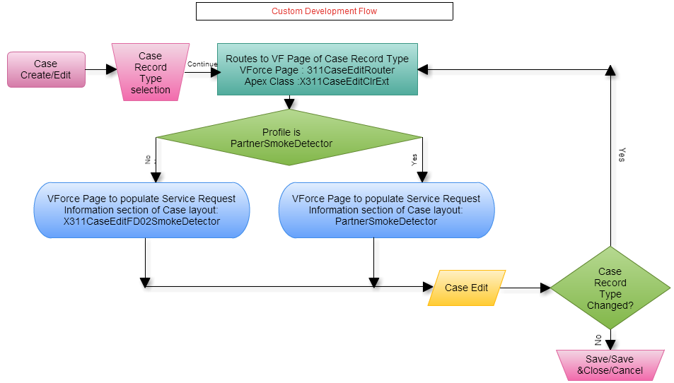

**Custom Flow :** For standard button New/Edit button is replaced with a custom Visualforce Page **X311CaseEditRouter**. All the Visual force pages and related extensions are defined as follows.

**Visual Force Page : X311CaseEditRouter**

**Purpose:**  To route to SR specific Visual force page.

<apex:page standardcontroller="Case" extensions="X311CaseEditClrExt" action="{!redir}">

</apex:page>

**Apex Class : X311CaseEditClrExt**

public PageReference redir() {

* + - 1. Get current page parameters.
      2. Get the relevant Page depending on the Profile and Record Type(X311CaseEditNS01Graffiti or PartnerGraffitiRemoval)..
      3. Redirect to the page with parameters.

}

**Visual Force Page : X311CaseEditFD02SmokeDetector**

<apex:page standardcontroller="Case">

<apex:composition template="X311CaseEdit">

<apex:define name="typeSpecific">

<apex:pageblocksection title="Service Request Information" showheader="true" collapsible="true" columns="2">

**SR Smoke Detector SPECEFIC FIELDS**

</apex:pageblocksection>

</apex:define>

</apex:composition>

</apex:page>

**Visual Force Page : X311CaseEdit**

<apex:page standardcontroller="Case" extensions="X311CaseEditClrExt">

<apex:pageblock mode="edit">

<apex:pageblocksection title="Department Details">

</apex:pageblocksection>

<apex:pageblocksection title="Case Information">

</apex:pageblocksection>

<apex:pageblocksection title="Service Request Location">

</apex:pageblocksection>

<apex:inputTextArea id="caseInternalComments" >

</apex:pageblocksection>

<apex:pageblocksection title="Description Information">

</apex:pageblocksection>

<apex:pageblock>

</apex:page>

**Visual Force Page : PartnerSmokeDetector**

<apex:page standardcontroller="Case" extensions="X311CaseEditClrExt">

<apex:pageblock mode="edit">

<apex:pageblocksection title="Department Details">

</apex:pageblocksection>

<apex:pageblocksection title="Case Information">

</apex:pageblocksection>

<apex:pageblocksection title="Service Request Location">

</apex:pageblocksection>

<apex:inputTextArea id="caseInternalComments" >

</apex:pageblocksection>

<apex:pageblocksection title="Service Request Information" showheader="true" collapsible="true" columns="2">

**SR Smoke Detector SPECEFIC FIELDS**

</apex:pageblocksection>

<apex:pageblocksection title="Description Information">

</apex:pageblocksection>

<apex:pageblock>

</apex:page>

**Triggers**

|  |  |  |  |  |  |
| --- | --- | --- | --- | --- | --- |
| **Trigger Name** | **Parent**  **Object** | **Child**  **Object** | **Trigger**  **Event** | **Operation**  **Type** | **Description** |
| CalculateBusinessHoursAges | Case |  | Before update | Insert | Calculates the total business hours between when a case was opened and when it was closed and then populates “Case Age in Business Hours” field, which is displayed in the “Age to Close in Business Hours” field shown within the “Resolution Information” section of the case |
| Account_Name_Update | Contact |  | Before update | Insert | When a new Contact is created during the case creation process, the system does not allow for an Account to be associated to the Contact, yet Account is a required field for a Contact. Whenever a new Contact is created without an Account, this trigger will associate the Account record with Name = “City of Philadelphia” to the Contact record |

**Apex Code:**

**Force.com sites:**

**Javascript:**

**Web Service/API Code:**

**Customer Portals:**

**Communities:** Community Partner Self-Service Portal

**Site.com:**

**Third Party Applications:**  Survey Force, Sales for Social Media & Call Center Console

**Other**

**Layout:** Smoke Detector

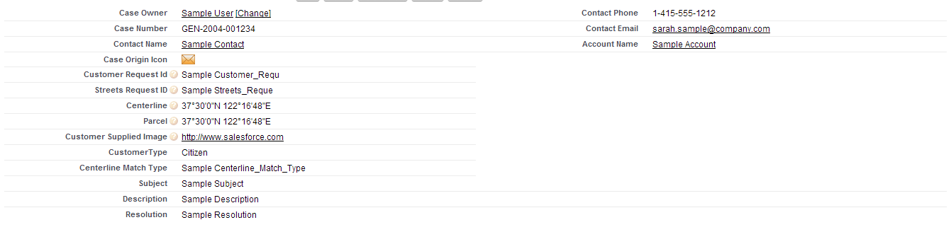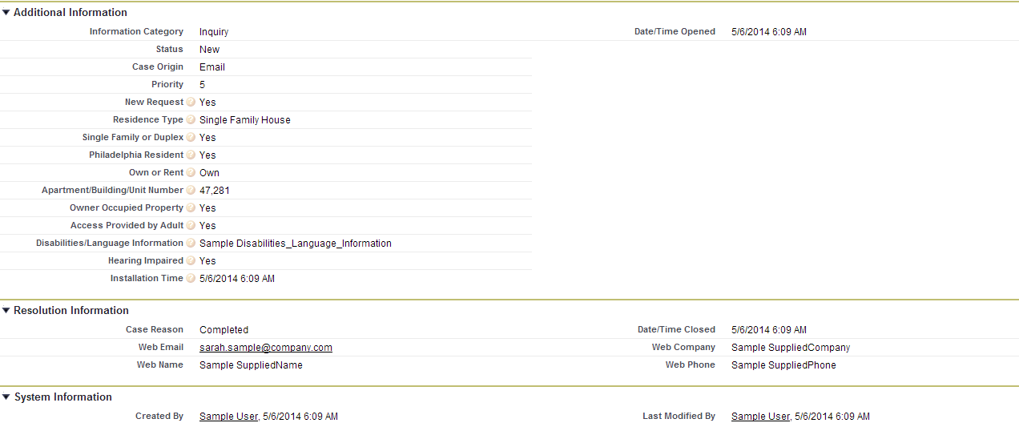

Related Lists :

* Solutions
* Open Activities
* Activity History
* Case Comments
* Case History
* Attachments

# 4 – STANDARD CASE FIELDS

|  |
| --- |
| 4.1 DEPARTMENT DETAILS SECTION |

|  |  |  |  |  |  |  |  |  |  |  |  |
| --- | --- | --- | --- | --- | --- | --- | --- | --- | --- | --- | --- |
| **Field Label** | **Field Name** | **Field Type** | **Custom** | **Default** | **Required** | **Unique** | **Read Only** | **External ID** | **Validation** | **History** | **Comments** |
| Type | Type | Picklist  **Values:** Service Request Type, Information Request Type, Directory Services | N | Service Request Type | Y |  | N | N | None | Y | Field is initially auto-populated based on the Case Record Type being created. If this value is manually changed, it will result in a new Field Layout based on the new Case Record Type. |
| Department | Department__c | Picklist  **Values:** Neighborhood Services | Y | Service Request Type | Y |  | N |  | None | N | Department will be automatically set based on Service Request Type. For an Information Request, this field will be automatically populated by the article. For Directory Services the field will default to 311 Services. |
| Service Request Type | Service_Request_Type__c | Picklist  **Values:** Graffiti Removal | Y | Graffiti Removal | Y |  | N |  | None | Y | This field is initially auto-populated based on the Case Record Type chosen when creating the case. If this value is changed, it could result in a new Field Layout based on the new Case Record Type chosen.  If any value in the Other Case Information systems indicates that this should not be forwarded to another department as a Service Request, a value of “Request Not Required” will be assigned to this field, which will indicate that the Case should be closed upon save without being assigned to a queue. |

|  |
| --- |
| 4.2 CASE DETAIL/INFORMATION SECTION |

**NOTE :** Section Header has to be “Case Information” in the layout when case is created or opened for modification. Other wise, Section Header is “Case Detail” .

| **Field Label** | **Field Name** | **Field Type** | **Custom** | **Default** | **Required** | **Unique** | **Read Only** | **External ID** | | **Validation** | **History** | **Comments** |
| --- | --- | --- | --- | --- | --- | --- | --- | --- | --- | --- | --- | --- |
| Case Owner | Owner | Lookup(User,Queue) | N |  | N |  | N | N | None | | Y | When a case is created this field is set to the User creating the case. Upon save, the Standard Case Assignment Rule is executed and this field is updated to a Queue based on the case’s Service Request Type. Once the case is saved this field can be manually changed by a user. |
| Case Number | CaseNumber | Auto Number | N |  | N | Y | Y | N | None | | N | The system automatically populates this field when a case is created. |
| Caller Zip Code | Caller_zip_code__c | Lookup(Contact) | Y |  | Y |  | N | N | None | | Y | This field will be populated by the Zip Code in the Contact record if one is associated with the case, otherwise the agent may populate it with a number from the caller. |
| Contact Name | Contact | Lookup(Account) | N |  | N |  | N | N | None | | Y | This field contains the Contact requesting the service. Ideally every case should have an associated contact. |
| Account Name | Account | Lookup(Account) | N |  | N |  | N | N | None | | N | This field contains the Account associated with the Contact record. |
| Parent Case | Parent | Lookup(Account) | N |  | N |  | N | N | None | | N | Two cases can be associated to each other via a parent/child relationship. This field identifies the “Parent” case. “Child” cases are displayed in the “Related Cases” Related List section for the “Parent” case. |
| Case Origin icon | Origin | Formula(Text) | Y |  | N |  | Y | N | None | | N | Shows an image representing the value in the Case Origin field. The formula for this field is: IMAGE(  CASE( Origin,  "Email", "https://<SalesforceOrg>.content.force.com/servlet/servlet.FileDownload?file=015K0000000238q",  "Phone", "https://<SalesforceOrg>.content.force.com/servlet/servlet.FileDownload?file=015K0000000238R",  "Web", "https://<SalesforceOrg>.content.force.com/servlet/servlet.FileDownload?file=015K000000023QL",  "/s.gif"),  "Origin Flag") |
| Contact Phone | ContactPhone | Phone | N |  | N |  | Y | N | None | | N | This display-only field is from the “Phone” field on the Contact record associated to the case. |
| Contact Email | ContactEmail | Email | N |  | N |  | Y | N | None | | N | This display-only field is from the “Email” field on the Contact record associated to the case. |
| Status | Status | Picklist  **Values:** On Hold, Escalated, Closed, New, In-Progress | N | New | Y |  | N | N | None | | Y | This required field defines the status of the case.   * “New” is the default value when creating a case. * All values except “Closed” are available when creating or editing a case.   “Closed” is the only value that can be selected when the “Close Case” button is used. |
| Case Origin | Origin | Picklist  **Values:** Email, Phone, Web | N | Phone |  | Y | N | N | None | | Y | This optional field provides the in-depth description of the case. |
| Priority | Priority | Picklist  **Values:** 1,2,3,4,5,6,7,8,9 | N | 5 |  | N | N | N | None | | N | This field allows a user to easily create a Comment while creating or editing a case. The data entered in this field will be used by the system to create a Comment record that will be displayed in the “Case Comments” Related List section of the case. |

## 

|  |
| --- |
| 4.3 SERVICE REQUEST LOCATION SECTION |

|  |  |  |  |  |  |  |  |  |  |  |  |
| --- | --- | --- | --- | --- | --- | --- | --- | --- | --- | --- | --- |
| **Field Label** | **Field Name** | **Field Type** | **Custom** | **Default** | **Required** | **Unique** | **Read Only** | **External ID** | **Validation** | **History** | **Comments** |
| Street | Street__c | Text(255) | Y |  | N |  | N |  |  |  | Street of the Service Request Location. Also see Standard Workflow Rules. |
| City | City__c | Text(255) | Y |  | N |  | N |  |  |  | City of the Service Request Location. Also see Standard Workflow Rules. |
| State | State__c | Text(255) | Y |  | N |  | N |  |  |  | State of the Service Request Location. Also see Standard Workflow Rules. |

|  |
| --- |
| 4.4 CASE LOCATION SECTION |

Defined in GIS Integration Detailed Design Document.

|  |
| --- |
| 4.5 DESCRIPTION INFORMATION SECTION |

|  |  |  |  |  |  |  |  |  |  |  |
| --- | --- | --- | --- | --- | --- | --- | --- | --- | --- | --- |
| **Field Label** | **Field Name** | **Field Type** | **Custom** | **Default** | **Required** | **Read Only** | **External ID** | **Validation** | **History** | **Comments** |
| Subject | Subject | Text(255) | N |  | Y | N |  |  | Y | If this field is populated when creating a new case, the system will find and display Knowledgebase Articles using the content in the “Subject” field. |
| Description | Description | Long Text Area(32000) | N |  | Y | N |  |  | Y | This optional field provides the in-depth description of the case. |
| Internal Comments | Comments | Text Area(4000) | N |  | N | N |  |  | N | This field allows users to enter a Comment while creating or editing a case. Data entered in this field will be used by the system to create a Comment record that will be displayed in the “Case Comments” Related List section of the case. |

|  |
| --- |
| 4.6 RESOLUTION INFORMATION SECTION |

NOTE: Case Detail page have these fields only be populated if the case is “closed”.

| **Field Label** | **Field Name** | **Field Type** | **Custom** | **Default** | **Required** | **Read Only** | **External ID** | **Validation** | **History** | **Comments** |
| --- | --- | --- | --- | --- | --- | --- | --- | --- | --- | --- |
| Close Reason | Close_Reason__c | Formula (Text) Formula : TEXT(Reason) | Y |  | N | Y |  |  | N |  |
| Resolution Description | Resolution_Description__c | Formula (Text) Formula : TEXT(Issue_Resolution__c) | Y |  | N | Y |  |  | N |  |
| Date/Time Closed | ClosedDate | Date/Time | N |  | N | Y |  |  | N |  |
| Age to Close in Business Hours | Age_to_Close_in_Business_Hours__c | Formula(Number) | Y |  | N | Y |  |  | N | CalculateBusinessHoursAges trigger would update this field |
|  |  |  |  |  |  |  |  |  |  |  |

NOTE: Following fields is shown in Resolution Info section.

|  |  |  |  |  |  |  |  |  |  |  |
| --- | --- | --- | --- | --- | --- | --- | --- | --- | --- | --- |
| **Field Label** | **Field Name** | **Field Type** | **Custom** | **Default** | **Required** | **Read Only** | **External ID** | **Validation** | **History** | **Comments** |
| Case Age in Business Hours | Case_Age_In_Business_Hours__c | Number(15,3) | N |  | N | Y |  |  | Y | CalculateBusinessHoursAges trigger would update this field |
| Case Reason | Reason | Picklist Values: Emergency Call, Invalid, Other, Question Answered | N | Question Answered | Y | N |  |  | Y |  |
| Issue Resolution | Issue_Resolution__c | Text Area(255) | Y |  | N | N |  |  | Y |  |

## 

|  |
| --- |
| 4.6 WEB INFORMATION SECTION |

NOTE: Section is shown only when the case is created through social media channels.

| **Field Label** | **Field Name** | **Field Type** | **Custom** | **Default** | **Required** | **Read Only** | **External ID** | **Validation** | **History** | **Comments** |
| --- | --- | --- | --- | --- | --- | --- | --- | --- | --- | --- |
| Web Email | SuppliedEmail | Email | N |  | N | Y |  |  | N |  |
| Web Name | SuppliedName | Text(80) | N |  | N | Y |  |  | N |  |
| Web Company | SuppliedCompany | Text(80) | N |  | N | Y |  |  | N |  |
| Web Phone | SuppliedPhone | Text(40) | N |  | N | Y |  |  | N |  |

|  |  |  |  |  |  |  |  |
| --- | --- | --- | --- | --- | --- | --- | --- |
| 4.7 SYSTEM INFORMATION SECTION | | | | | | | |
| **Field Label** | **Field Name** | **Field Type** | **Custom** | **Default** | **Required** | **Read Only** | **External ID** | | **Validation** | **History** | **Comments** |
| Created By | CreatedBy | Lookup(User) | N |  | N | Y |  | |  | N |  |
| Last Modified By | LastModifiedBy | Lookup(User) | N |  | N | Y |  | |  | N |  |

Additional comments: